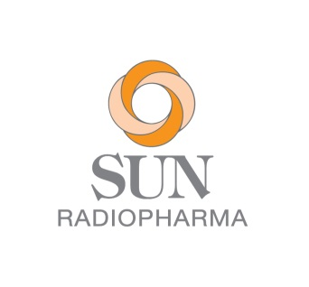
August 14th, 2023

Radiopharmaceutical Tc99m Kit Supply Update

Dear Customers,

As stated in our last communication on March 29th, 2023, Sun Radiopharma is experiencing a supply interruption for several radiopharmaceutical products. We understand how disruptive this has been for you, and we are committed to resuming supply as quickly as possible.

The dates of the Product Release Schedule below are “best estimates” and are subject to change.
Product Release Schedule

- Sulfur Colloid: Available now
- Medronate (MDP): Mid November
- Pyrophosphate: Mid October
- Mebrofenin: Available now
- Mertiatide: Mid November

Note: Sestamibi has been discontinued until further notice. Pending orders have been cancelled.

Once again, we sincerely apologize for the supply interruption and the delay of some products returning to market. Thank you for your continued understanding. We are committed to re-gaining your confidence and providing you with world-class service. We will continue to keep you informed as we work to resume supply of these critical products.

If you have any questions, or would like to place an order, kindly contact our Customer Service group by sending an email to Radiopharma.Customerservice@sunpharma.com or by calling 800-221-7554.

Sincerely,

Mickey O’Neill

Mickey O’Neill
Customer Support Specialist, RadioPharma

29 Dunham Road Billerica, MA 01821 Phone 781.275.7120 Fax 781.275.5191
www.sunradiopharma.com

